You and Your Customer can earn up to $100 in Dec!
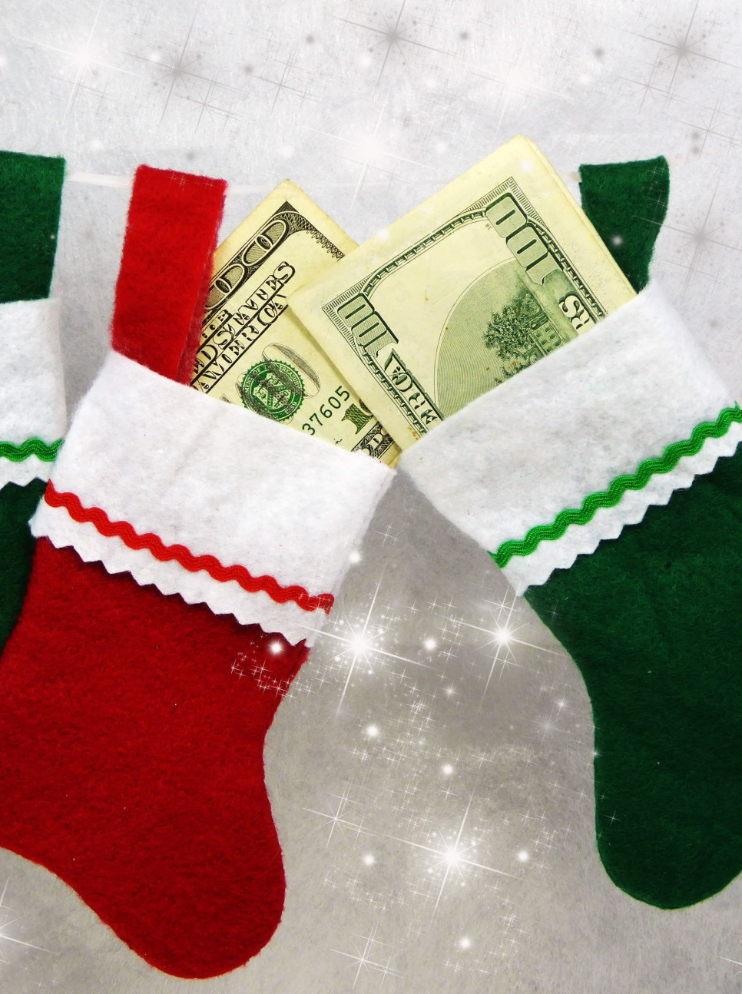
Consultants: 3 winners: 1st, 2nd, and 3rd place, $100, $50, $25
Customers: 1 winner $100
(we must hit our goal of 100 faces as a unit to hit our goal)

Use the Tracking Sheet!

Points For Consultants to Win (Track your Points)
- Each Face Pampered (1pt)
- Each Career Chat w/ Director (2pts)
- Each Party with 3 or More (5pts)
- Have 5 Bookings on your books by the 6th (5 pts)
- Have 8 Bookings on your books by the 6th (10 pts)
- Have 10 Bookings on your books by the 6th (20 pts)
- Each $100 Day (2pts)
- Each New Team Member (10 pts)
- Each tell us what you think Form Turned in (2 pts)
- Each Gift Set/ Basket Sold (1pt)
- Each Adopt A Grandparent Sold (1pt)
- Each Day You Get 5 New Leads (2pts)
- Placed a 600 ws (10 pts)
- Placed a 1000 or more ws (20 pts)

Points For Customers to Win (Track Each Pt)
- Have a Facial/attend a Party (1 pt)
- Every $50 purchase (2 pts)
- Doing a Career Chat with Consultant and Director (5 pts)
- Signing up as a Consultant (10 pts)
- Being A Hostess with 3 or more(10 pts)
- Booked an Appt with you between Dec. 1-15 (10 pts)
- Booked an Appt with you between Dec. 16-31st (15 pts)
- Every 5 referrals given (2 pts)

